Project: Woodson Park Academy & YMCA-ELC
Week Ending: July 26th, 2019

THIS WEEK:
- Level Construction to walk site looking at tires that need removed.
- Site Crew continued pond
- COA watershed is installing new 8” water line off of Hollowell with no cost to this project.
- Tree crew started cutting down trees
- LDP obtained at noon on 7/24.
- Haul off of trees began

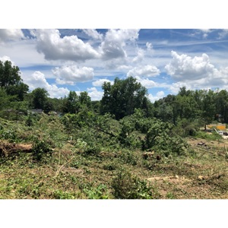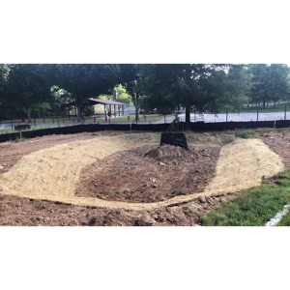

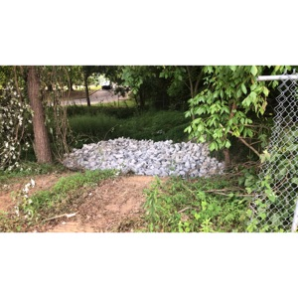

NEXT WEEK – July 29 thru August 2:
- Building demo crew to start next Tuesday 7/30.
- Clear and grub crew to restart on Monday 7/29 to clean up site for demo crew to get started on slabs and footings
- Install web cam

PAYMENT STATUS:
- Gmp#1 $3,703,488.00
  - Paid to date amount $0.00
- GMP#2 $28,686,295.00
  - Paid to date amount $0.00

SCHEDULED DATE OF SUBSTANTIAL COMPLETION
- WPA – September 17, 2020
- YMCA-ELC - September 14, 2020

PREPARED BY:
- Matt Dauber, Carroll Daniel Construction Co.

